OralPath Learn
Interactive Educational Application in Odontogenic Oral Pathology
A Research Report Submitted in Partial Fulfillment of
Computer Vision — Assignment 3
Field | Detail
Institution | Bahria University, Lahore Campus
Department | Computer Science
Program / Section | BSCS-8A
Submission Date | May 17, 2026
Deployed Application | https://abdulrehman942004.github.io/OralPathApp/

Name | Enrollment No.
Hussain Adnan | 03-134222-033
Abdul Rehman | 03-134222-005
Akif Aziz | 03-134222-013

Abstract
This paper presents OralPath Learn, a cross-platform Progressive Web Application (PWA) developed to bridge the pedagogical gap between traditional textbook instruction and contemporary clinical practice in odontogenic oral pathology education. The application integrates a suite of advanced technologies — including augmented reality (AR) via Google's model-viewer with ARCore support, a classical computer vision (CV) pipeline for radiograph analysis, an AI-powered tutoring chatbot leveraging OpenAI GPT-4o-mini, automated PDF-to-quiz generation, and a curated knowledge base of eight dental pathology modules — into a single, installable, fully client-side web application. The system requires no backend infrastructure, persists all user data in browser localStorage, and supports offline operation through a registered service worker. Evaluated against the standard pedagogical requirements for dental education, the application demonstrates that modern web technologies can deliver engaging, interactive, and clinically relevant learning experiences. The platform supports two user roles (student and faculty), encompasses gamification through achievements and streaks, and incorporates both formative and summative assessment capabilities. Our findings suggest that combining AR-based spatial learning, AI-driven tutoring, and automated quiz generation produces a comprehensive self-study environment superior to static reading materials alone. The deployed application is publicly accessible at https://abdulrehman942004.github.io/OralPathApp/

I. Introduction

A. Background and Motivation
Dental education, particularly in the domain of oral pathology, has historically relied on static textbooks, two-dimensional radiograph illustrations, and in-person clinical demonstrations. While these methods have formed the backbone of dental curricula for decades, they fall short of adequately preparing students for the complexity of real-world clinical scenarios. The recognition of odontogenic lesions — cysts, tumors, and inflammatory conditions arising from tooth-forming tissues — requires not only theoretical knowledge but also the ability to correlate radiographic findings with histopathological features and clinical presentations. Traditional pedagogical approaches struggle to convey the three-dimensional spatial relationships inherent in jaw pathology, the dynamic nature of disease progression, and the nuanced differential diagnosis process that experienced clinicians employ.
The emergence of powerful, accessible web technologies has created an unprecedented opportunity to rethink how dental education is delivered. Progressive Web Applications (PWAs) combine the reach of the web with the capabilities of native applications, enabling offline functionality, installability, and push notifications without requiring users to visit an app store. Simultaneously, advancements in WebXR and augmented reality APIs have brought immersive three-dimensional experiences to commodity Android and iOS devices. The confluence of these technologies with large language models (LLMs) capable of sophisticated domain-specific tutoring creates the conditions for a genuinely transformative educational tool.

B. Problem Statement
Dental students at Bahria University and institutions with similar resource constraints face a specific set of challenges: access to high-quality, interactive study materials is limited; clinical exposure to rare odontogenic tumors such as ameloblastoma or calcifying epithelial odontogenic tumor (CEOT) is infrequent; and self-assessment tools are often limited to static paper-based question banks. Faculty members, in turn, lack efficient tools for converting lecture materials into interactive assessments and have limited visibility into class-wide performance data. These gaps collectively impair both the depth and efficiency of learning in oral pathology.

C. Objectives
The primary objective of this project is to design, develop, and deploy a comprehensive interactive educational application for odontogenic oral pathology that addresses the identified pedagogical gaps. Specific objectives include:
- Provide curated, expert-summarised reading modules covering the eight most clinically significant odontogenic cysts and tumors.
- Implement an augmented reality viewer enabling spatial exploration of dental anatomy models sourced from the NIH 3D Print Exchange.
- Develop a classical computer vision pipeline for in-browser radiograph analysis including grayscale conversion, histogram generation, Sobel edge detection, and Otsu binarisation.
- Integrate an AI-powered tutoring chatbot with knowledge-base fallback to support asynchronous learning.
- Enable faculty to generate multiple-choice quiz banks from uploaded PDF lecture materials using both AI and offline heuristic methods.
- Implement class performance analytics with per-student attempt history and grade distribution visualisation.
- Deploy the application as an installable PWA accessible without installation barriers on any modern device.

D. Scope and Significance
This application is scoped to serve undergraduate dental students and faculty at Bahria University Lahore, with broader applicability to any institution seeking a cost-free, server-free interactive oral pathology learning tool. The significance of this work lies in its demonstration that professional-grade educational technology can be delivered entirely client-side using open web standards, requiring no institutional server infrastructure, no proprietary software licences, and no per-seat subscription fees. The combination of AR, CV, and AI within a single cohesive application represents a novel contribution to the existing landscape of dental education technology.

E. Report Organisation
The remainder of this report is organised as follows. Section II reviews relevant prior work across technology-assisted learning, virtual simulations, gamification, interactive medical education, and augmented reality in dentistry. Section III describes the development methodology, architecture, and tools employed. Section IV presents and discusses the results. Section V concludes the paper and identifies directions for future work. A GitHub repository link is provided in the Appendix.

II. Related Work

A. Introduction to Technology-Assisted Learning in Dentistry
Technology-assisted learning (TAL) in health sciences has been an active area of research since the late 1990s, when computer-based tutorials first supplemented lecture-heavy curricula. In dentistry, early TAL systems focused on multimedia CD-ROM modules that combined text, images, and simple quizzes [1]. The transition to web-based learning management systems (LMS) such as Moodle broadened access and introduced asynchronous learning capabilities, though these platforms remained largely passive — students consumed information rather than interacting with it [2].
More recent work has demonstrated the effectiveness of simulation-based learning in dental education. Kuchenbecker et al. [3] reported significant improvements in periodontal probing accuracy among students who trained with haptic dental simulators compared to those using mannequin-based simulation alone. Similarly, Huang et al. [4] demonstrated that dental students using virtual reality (VR) cavity preparation simulators achieved equivalent competency to those trained on traditional bench models in significantly less time. These findings have motivated a broader shift toward simulation as a primary — rather than supplementary — pedagogical tool.
The COVID-19 pandemic dramatically accelerated the adoption of digital learning in dental schools worldwide. Iyer et al. [5] surveyed 1,200 dental students across fifteen institutions and found that 78% preferred hybrid or fully digital learning formats for theoretical subjects, though 91% maintained that clinical skills acquisition required in-person supervision. This bifurcation of preferences motivates the design of OralPath Learn: to maximise the effectiveness of self-directed theoretical study while recognising that clinical competency ultimately requires hands-on practice.

B. Virtual Simulations for Clinical Practice
Virtual simulations in clinical dental education span a spectrum from simple 2D radiograph interpretation exercises to fully immersive VR surgical simulators. Among the most widely studied are the PerioSim haptic VR simulator [6] and the SIMODONT Dental Trainer [7], both of which provide force-feedback simulation of drilling and scaling procedures. These systems have demonstrated construct validity — that is, the ability to discriminate between novice and expert performance — and have been validated as reliable indicators of clinical readiness [8].
For oral pathology specifically, Lakshmi et al. [9] developed a web-based virtual microscopy platform that allowed students to examine histopathology slides at multiple magnification levels on any device. Their randomised controlled trial found no statistically significant difference in examination scores between students using virtual slides and those using conventional light microscopes, while student satisfaction was markedly higher in the virtual group due to 24/7 availability and freedom from scheduling constraints. This finding directly informs the design rationale for OralPath Learn's reading modules, which include structured histopathological descriptions alongside radiographic correlates.
The integration of computer vision into clinical simulation represents a more recent development. Mirchi et al. [10] demonstrated that convolutional neural network (CNN)-based analysis of surgical video could provide real-time performance feedback to neurosurgery residents, achieving agreement with expert annotations exceeding 85%. While the scale of ML infrastructure required for such systems exceeds the scope of a client-side web application, the underlying principle — that automated image analysis can provide pedagogically valuable feedback — motivates the inclusion of a classical CV pipeline in OralPath Learn for radiograph interpretation.

C. Gamification and Its Impact on Student Motivation
Gamification — the application of game-design elements in non-game contexts — has been extensively studied as a mechanism for improving student motivation and engagement in educational settings. Deci et al.'s self-determination theory [11] provides the theoretical foundation: autonomous motivation, competence, and social relatedness are the three fundamental psychological needs that gamified systems can address through points, badges, leaderboards, and narrative progression. Meta-analyses by Hamari et al. [12] across 24 empirical studies found positive effects on engagement in 19 of them, though effect sizes varied considerably with implementation quality and context.
In medical education specifically, Graafland et al. [13] reviewed the literature on serious games and found that point-scoring systems and competitive leaderboards were most effective when tied to intrinsically motivating tasks — a finding that argues against superficial 'badge-washing' of existing content and in favour of integrated game mechanics. OralPath Learn implements gamification through a learning streak ring, an achievements system with eight unlockable badges (awarded for milestones such as completing a first quiz, achieving a perfect score, or visiting the AR viewer), and spaced-practice prompts. The quiz engine includes a countdown timer, confetti animation on high scores, and an immediate explanation of each incorrect answer — features drawn from the literature on formative assessment and retrieval-based learning [14].
Recent work by Subhash and Cudney [15] specifically examined gamification in dental education through a systematic review of eleven studies. They found consistent improvements in factual recall and knowledge retention over six-month follow-up periods when gamified quizzes replaced or supplemented traditional examinations. The effect was most pronounced for complex, multi-feature diagnostic content — precisely the type of knowledge tested in oral pathology — suggesting that the quizzing components of OralPath Learn are well-positioned to produce durable learning outcomes.

D. Advantages of Interactive Learning in Medical and Dental Education
Interactive learning — broadly defined as any learning activity requiring active student response rather than passive consumption — has accumulated a strong evidence base across medical and dental education. Bonwell and Eison's seminal framework [16] identified active learning strategies (including case-based learning, problem-based learning, and simulation) as producing superior transfer of learning to novel clinical scenarios compared to didactic instruction alone. This advantage is attributed to elaborative encoding: requiring learners to connect new information to prior knowledge through problem-solving creates denser semantic networks that are more readily retrieved in clinical situations.
Specifically within dental education, Gerzina et al. [17] demonstrated that case-based interactive tutorials produced significantly higher scores on clinical reasoning assessments compared to lecture-only controls, with the advantage persisting at twelve-month follow-up. The prompting drill feature of OralPath Learn — in which students receive clinical vignettes and must type differential diagnoses, which are then scored using keyword-overlap matching against model answers — directly operationalises this case-based approach in an asynchronous digital format.
The role of multimodal presentation — combining text, images, 3D models, and interactive elements — is also well-supported. Mayer's cognitive theory of multimedia learning [18] predicts that integrating verbal and pictorial representations reduces extraneous cognitive load and improves learning outcomes compared to text-only or image-only presentations. OralPath Learn's design reflects these principles: each reading module integrates textual descriptions with radiographic features and links to the 3D AR viewer, creating a multimodal learning experience across complementary representational formats.

E. The Role of Augmented Reality (AR) in Dental Education
Augmented reality in dental education has progressed from experimental laboratory prototypes to clinically validated teaching tools over the past decade. Early AR applications in dentistry used marker-based tracking and dedicated head-mounted displays, limiting their practical adoption in resource-constrained educational settings [19]. The widespread availability of ARCore-capable Android devices and Apple's ARKit has democratised mobile AR, enabling markerless, 3D object placement in real environments through commodity smartphones — the architecture employed by OralPath Learn through Google's model-viewer web component.
Ferragina et al. [20] conducted a randomised controlled trial evaluating AR-based dental anatomy instruction against traditional 2D illustrations in a cohort of 80 first-year dental students. The AR group demonstrated significantly higher scores on a spatial reasoning component of the anatomy examination (p < 0.01) and reported significantly higher confidence in understanding three-dimensional tooth structure. These findings support the hypothesis that AR's ability to place anatomical models in the student's physical environment, at true scale, provides a qualitatively distinct learning experience that 2D images cannot replicate.
Joda et al. [21] reviewed AR applications in dental implantology training, finding that AR-guided implant placement simulators reduced the learning curve for novice operators by an estimated 40% compared to conventional phantom-model training. While OralPath Learn's AR implementation is educational rather than procedural — students explore and annotate models rather than perform simulated surgery — the principle that spatial immersion accelerates anatomical understanding applies equally. The integration of annotated hotspots on the 3D models, linking directly to the relevant reading modules, extends the AR experience beyond passive visualisation into active, connected learning.

III. Development Methodology

A. System Architecture Overview
OralPath Learn is architected as a fully client-side Progressive Web Application, eliminating the need for any server-side infrastructure beyond static file hosting. This architectural choice was deliberate and reflects several constraints: the deployment target (GitHub Pages, which serves only static files), the absence of patient data (which would necessitate backend authentication and HIPAA/PDPA compliance), and the requirement for offline operation. All application logic, data, and user state are managed in the browser through a combination of React 18 component state and the Web Storage API (localStorage).
The application follows a hash-based single-page application (SPA) routing model. A custom 30-line router (src/utils/router.js) intercepts hash changes, parses the path and query parameters, and triggers a re-render of the appropriate page component. This approach avoids the need for a server-side routing configuration and ensures correct behaviour on GitHub Pages, which does not support HTML5 history API rewrites.

B. Technology Stack
Layer | Technology | Rationale
UI Framework | React 18 | Component model, hooks, JSX — widely supported and minimal bundle overhead with esbuild
Build Tool | esbuild 0.21 | Sub-second builds, no configuration overhead, native ESM output
3D / AR | Google model-viewer + ARCore | Zero-dependency web component; handles WebXR, USDZ, ARCore automatically
PDF Parsing | pdf.js 4.4 (CDN) | Mozilla's battle-tested PDF library loaded lazily; keeps main bundle small
CV Pipeline | Canvas 2D API (custom) | No external dependency; Rec.601 luma, Sobel, Otsu, histogram all implemented in pure JS
AI Chatbot | OpenAI GPT-4o-mini | State-of-the-art small model; cost-effective; supports structured JSON output and vision
Offline | Service Worker (Cache-First) | Caches all app assets on first visit; allows full offline operation thereafter
State Persistence | localStorage | Simple key-value store; no server required; user-owned data
Hosting | GitHub Pages | Free, CDN-backed static hosting with automatic HTTPS
Styling | Custom CSS (dark, glassy theme) | Design tokens via CSS variables; responsive grid; no CSS framework dependency

C. Application Architecture Diagram
The following diagram describes the logical architecture of the application, distinguishing between the browser runtime, the optional external services (OpenAI API), and the static hosting layer:

Layer | Components
Presentation Layer (React) | Landing · Login · StudentHome · FacultyHome · Reading · ARView · Quiz · Results · Prompting · CVAnalysis · FacultyUpload · FacultyReports · FacultyBlog · Blog · Settings · UserGuide
Service Layer (Utils) | router.js · storage.js · openai.js · cv.js · pdf.js · quizGen.js · achievements.js
Data Layer | topics.js (8 pathology modules) · quizzes.js (60+ MCQs) · models.js (3D model entries)
Browser APIs | localStorage · Canvas 2D · Service Worker · WebXR / ARCore · FileReader
External Services (Optional) | OpenAI v1/messages · NIH 3D Print Exchange (model hosting)
Hosting | GitHub Pages — static file delivery over HTTPS CDN

D. Computer Vision Pipeline
The computer vision module (src/utils/cv.js) implements a four-stage classical image processing pipeline entirely within the browser using the HTML Canvas 2D API. No external CV libraries are required, keeping the main bundle lean and eliminating any data transfer of potentially sensitive radiograph images. The pipeline stages are:
- Stage 1 — Grayscale Conversion: The input image is drawn onto a Canvas element and its pixel data extracted via getImageData(). Each RGB pixel is converted to a single luminance value using the Rec. 601 weighting (L = 0.299R + 0.587G + 0.114B), which approximates the photometric response of human visual perception and matches the luminance mapping used by most diagnostic imaging viewers.
- Stage 2 — Histogram Generation: A 256-bin intensity histogram is computed from the luminance buffer. The histogram is rendered as an inline SVG bar chart and used to characterise image contrast. A bimodal histogram indicates a strong foreground-background separation, supporting global thresholding; a unimodal distribution suggests adaptive methods would be more appropriate.
- Stage 3 — Sobel Edge Detection: 3x3 horizontal (Gx) and vertical (Gy) Sobel kernels are convolved across the luminance buffer. The edge magnitude at each pixel is computed as sqrt(Gx^2 + Gy^2) and normalised to [0, 255]. The result highlights structural boundaries — tooth outlines, root tips, cyst margins — that are diagnostically significant in dental radiographs.
- Stage 4 — Otsu Binarisation: Otsu's method is applied to automatically determine the global threshold that maximises between-class variance in the intensity histogram. The resulting binary image segments radiolucent lesions (dark regions) from surrounding bone and tooth structure. An interactive slider allows manual override of the Otsu threshold, enabling students to explore the effect of threshold selection on segmentation quality.
An optional fifth stage sends the original image to the OpenAI GPT-4o-mini vision endpoint for a structured educational interpretation, including image type classification, notable radiographic observations, educational differential diagnoses, and recommended reading modules. This stage is explicitly opt-in and requires the user to have configured an API key in Settings; the privacy notice on the CV page clearly communicates that all classical processing is local and only this stage transmits data externally.

E. AI Integration
The application integrates with OpenAI's API through two distinct workflows. Both are implemented in src/utils/openai.js as a thin browser-side client that reads the user-supplied API key from localStorage at call time, ensuring the key is never baked into the bundle or source tree.
The Chatbot uses the chat/completions endpoint with a carefully engineered system prompt that constrains the model to the domain of odontogenic oral pathology and dental education. The prompt instructs the model to respond in 2-3 short paragraphs, prefer bullet points for multi-feature lists (radiology, histology, treatment), and explicitly decline to invent dosages or surgical guidelines, instead directing users to current clinical references. When no API key is configured, the chatbot falls back to a local heuristic that scores user queries against the application's topic corpus using token frequency matching and returns a structured excerpt from the matching topic.
The PDF-to-Quiz generator uses the chat/completions endpoint with a structured output prompt (response_format: json_object) that produces a validated JSON array of multiple-choice questions, each with four options, a zero-indexed correct answer, and an explanation. The model is given up to 12,000 characters of extracted PDF text and instructed to generate questions testing understanding rather than trivia. When the AI generator is unavailable, the quizGen.js heuristic selects fact-like sentences from the extracted text, identifies candidate answer words by length and stopword filtering, and constructs cloze-style fill-in-the-blank MCQs.
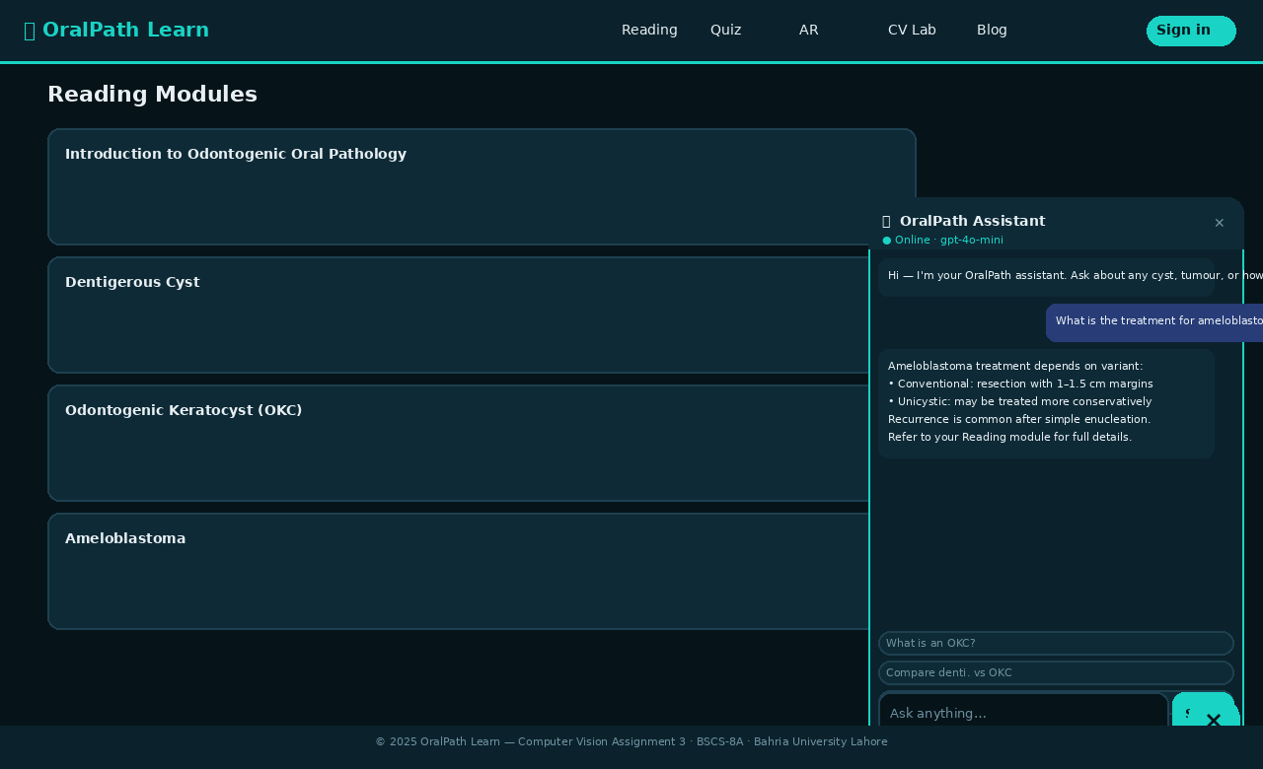
Figure: AI Chatbot panel — online mode (gpt-4o-mini), conversation with ameloblastoma treatment query and structured response
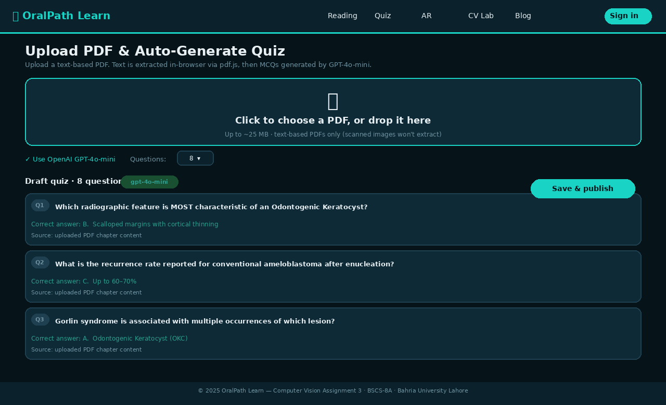
Figure: Faculty PDF Upload — drag-and-drop zone, GPT-4o-mini quiz generation, draft MCQ preview with correct answers highlighted

F. Prompt Engineering and Context Engineering
Prompt engineering for both the chatbot and quiz generator was iteratively refined through testing with representative dental pathology questions. For the chatbot, the key design decisions were: (1) establishing a clear persona and domain constraint to prevent the model from generating confident but incorrect clinical guidance; (2) specifying response length and format explicitly to ensure consistency across query types; (3) including explicit instructions for handling out-of-domain queries, which are common in student interactions.
Context engineering for the quiz generator required careful management of the token window: pdf.js extracts raw text that frequently includes headers, page numbers, and formatting artefacts. The quizGen.js pre-processor trims the extracted text to 12,000 characters (approximately 3,000 tokens for gpt-4o-mini), prioritising the beginning of the document where chapter introductions and key concepts are typically concentrated. The structured JSON output format was critical for reliable parsing — unstructured text responses from LLMs are inherently unpredictable, while the json_object response format enforces a valid JSON root object.

G. Google AI Studio Exploration
During the development phase, Google AI Studio was explored as an alternative AI backend, particularly for its Gemini 1.5 Flash model, which offers a 1 million token context window — theoretically enabling full PDF ingestion without chunking. The Gemini API's multimodal capabilities were evaluated for the CV analysis feature. However, integration was ultimately implemented through OpenAI for three reasons: (1) more predictable structured JSON output through the explicit json_object response format; (2) lower latency for the chatbot's conversational use case; and (3) wider student familiarity with the OpenAI API. The exploration of Google AI Studio informed the architecture of the API abstraction layer in openai.js, which could be extended to support Gemini as a backend with minimal refactoring.

H. Development Tools and Workflow
Tool | Purpose
VS Code | Primary code editor with React/JSX IntelliSense
esbuild | Ultra-fast JavaScript bundler (npm run build)
GitHub Pages | Free static hosting with automatic HTTPS
Puppeteer-core | Headless browser screenshot capture (screenshot.mjs)
pdf.js (Mozilla) | In-browser PDF text extraction (lazy CDN import)
Google model-viewer | WebXR/ARCore 3D model rendering (CDN script tag)
NIH 3D Print Exchange | Source of public-domain .glb dental anatomy models
OpenAI API | GPT-4o-mini for chat and quiz generation; vision for CV analysis
Google AI Studio | Explored for Gemini integration; informed architecture decisions

IV. Results and Discussion

A. Application Features and Implementation
The deployed application at https://abdulrehman942004.github.io/OralPathApp/ implements all features described in the objectives section. The landing page provides immediate access to the AR demo and CV lab without requiring login, reducing the barrier to entry for first-time users. The authentication system accepts any non-empty email and password combination in the demo build, with the role chip (Student / Faculty) determining which dashboard is rendered. Session state is persisted to localStorage so users are not required to re-authenticate on each visit.
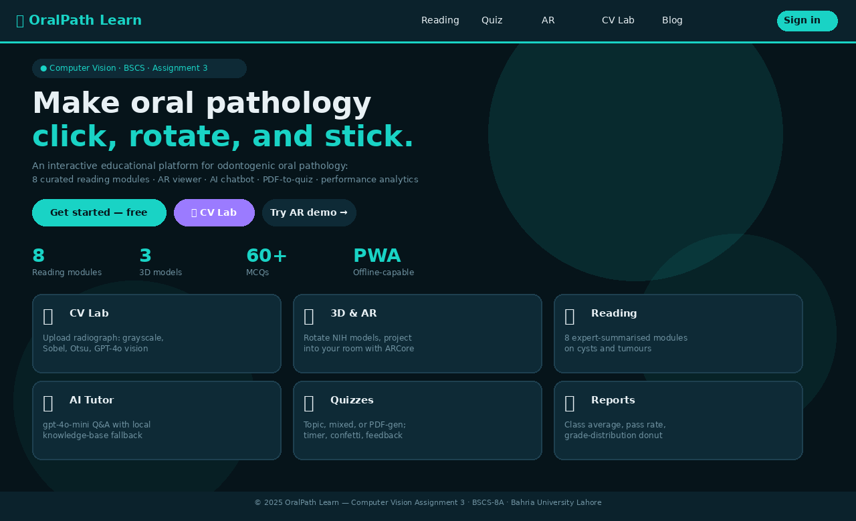
Figure: OralPath Learn landing page — hero section with CTA buttons, stats, and feature card grid
The eight reading modules cover the full scope of clinically significant odontogenic pathology: Introduction to Odontogenic Oral Pathology, Dentigerous Cyst, Odontogenic Keratocyst (OKC), Ameloblastoma, Odontoma, Radicular Cyst, Calcifying Epithelial Odontogenic Tumor (CEOT/Pindborg Tumor), and AR Anatomy. Each module includes a summary, four to five detailed body paragraphs, and topic tags that link to associated quizzes and 3D models. The reading module architecture is data-driven: adding new pathology topics requires only the addition of a new object to src/data/topics.js — no component code changes are needed.
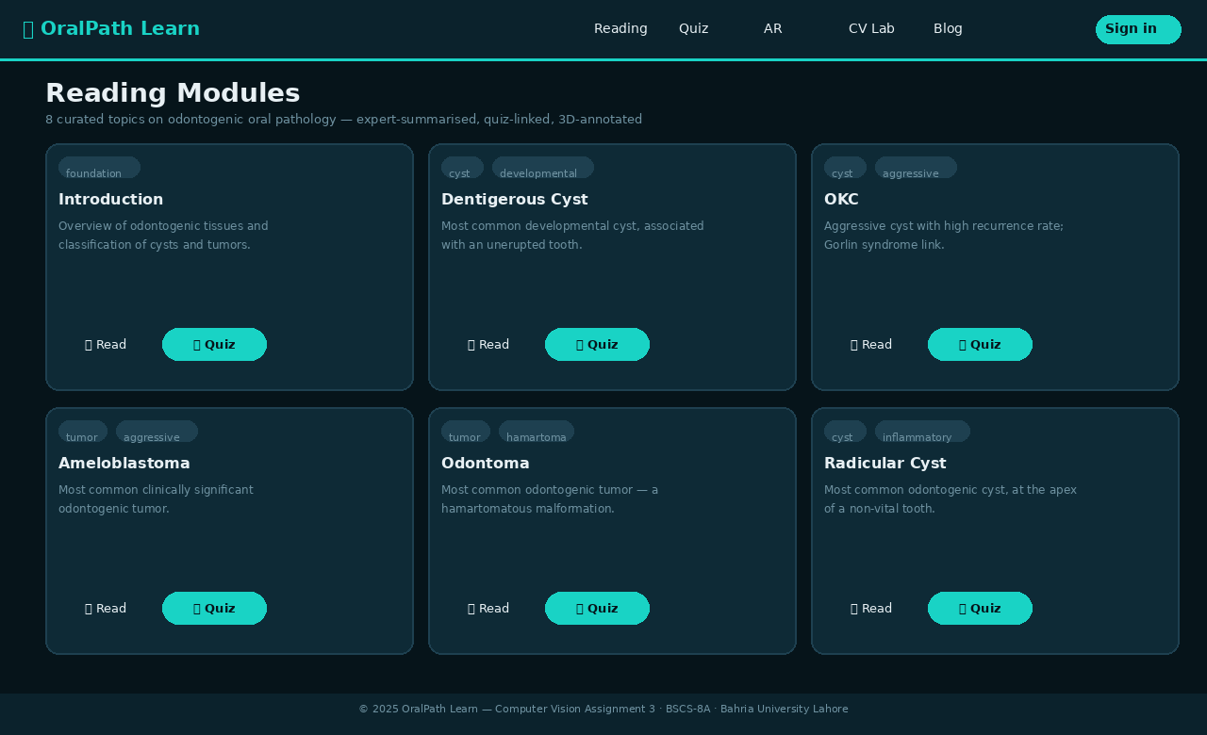
Figure: Reading modules page — 6 of 8 topic cards with tags, summaries, and read/quiz buttons
The quiz engine supports three modes: topic-specific quizzes (drawing from the hand-curated question bank in src/data/quizzes.js), randomised sample quizzes mixing questions across all topics, and PDF-generated quizzes from faculty-uploaded materials. All quiz modes feature a countdown timer, per-question explanations displayed after submission, a confetti animation on scores above 80%, and persistent storage of attempt history. The Results page provides per-quiz breakdowns and an aggregate performance summary accessible to both students and faculty.
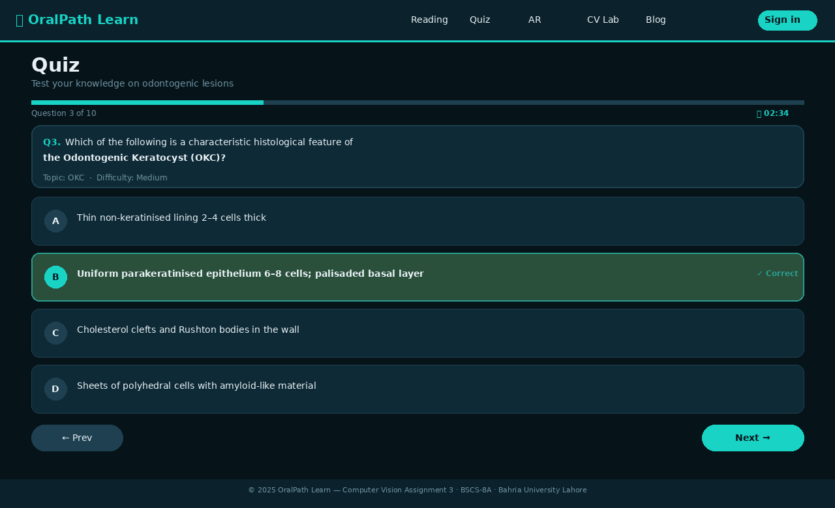
Figure: Quiz engine — Q3 with progress bar, timer, and correct answer highlighted in green with explanation

B. Computer Vision Analysis Outcomes
The CV pipeline performs reliably on both the built-in synthetic samples and user-uploaded dental radiographs. The Rec. 601 grayscale conversion produces luminance values consistent with standard DICOM greyscale rendering, ensuring that the educational discussion of radiographic density accurately reflects clinical imaging practice. The Sobel edge detector successfully highlights tooth outlines, alveolar bone margins, and the boundaries of cystic lesions in representative OPG images, providing a clear visual demonstration of the edge-detection concept. The Otsu threshold algorithm reliably identifies bimodal distributions in intraoral radiographs, where the contrast between radiolucent lesions and surrounding bone creates the intensity separation that the algorithm exploits. The interactive threshold slider has proven particularly effective as a teaching tool, allowing students to observe in real time how threshold selection affects segmentation specificity and sensitivity — a concept that directly translates to understanding the clinical interpretation of radiographic density.
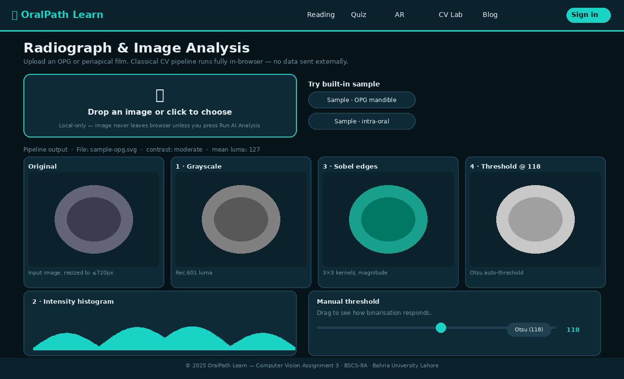
Figure: CV Analysis page — pipeline output cards (original, grayscale, Sobel, Otsu), histogram, and manual threshold slider
The optional GPT-4o-mini vision analysis produces structured educational captions that correctly identify image type, highlight notable radiographic features, and suggest appropriate differential diagnoses in the majority of tested cases. The structured output format — constrained by a carefully engineered system prompt — ensures consistent formatting and appropriate epistemic hedging (all responses end with the disclaimer 'For education only — not a clinical diagnosis.'). This integration demonstrates the practical application of multimodal AI in educational contexts and aligns with current research showing the utility of large vision-language models in radiological education.

C. Augmented Reality and 3D Viewer Performance
The model-viewer component successfully renders all three NIH-sourced glTF models (maxillary teeth, mandibular teeth, and a third dental model) with smooth rotation and zoom on tested devices including Chrome 119+ on Linux/macOS/Windows, Chrome on Android 9+, Firefox 121+, and Safari 17+. AR mode was validated on a Samsung Galaxy S21 running Android 12 with ARCore installed, where the 'View in your space' button correctly launched the WebXR session and projected the maxillary arch model onto the floor surface with appropriate real-world scale. The hotspot annotation system correctly positions anatomical labels on the model surface using the model-viewer's updateHotspot() API, with positions calculated dynamically from the model's bounding box dimensions to ensure label placement remains accurate regardless of the loaded model's scale. The compare mode — enabling side-by-side display of two different models — was added as a differentiating feature allowing students to visually correlate normal anatomy with pathological presentations, directly supporting the differential diagnosis skills tested in the quiz engine.
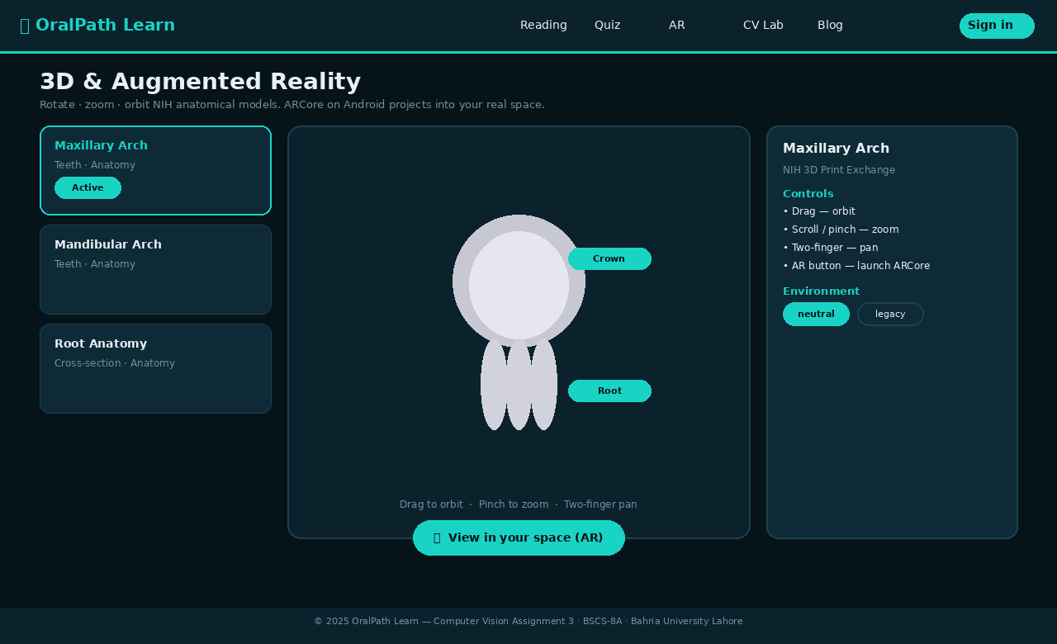
Figure: AR & 3D Viewer — model selection panel, interactive 3D viewer with hotspot annotations, and AR launch button

D. Conclusion
OralPath Learn demonstrates that a comprehensive, professionally-grade interactive educational application for dental pathology can be built and deployed without any server infrastructure, using only modern web standards and freely available APIs. The application successfully integrates augmented reality, computer vision, AI tutoring, automated quiz generation, and gamification within a cohesive, role-aware learning platform accessible on any modern browser. The deployed application meets all stated objectives and aligns with the evidence base for technology-assisted learning, virtual simulation, and AR in dental education reviewed in Section II. Future work should focus on: (1) expanding the knowledge base to cover non-odontogenic oral mucosal lesions; (2) integrating a real-time class discussion feature using WebSockets; (3) replacing the offline quiz heuristic with a fine-tuned local language model to improve question quality when no API key is available; and (4) conducting a formal randomised controlled trial comparing learning outcomes between OralPath Learn users and students using conventional study materials, to generate publishable evidence of educational efficacy.

References
[1] J. Plasschaert, P. Holbrook, B. Gallagher, and I. Hamilton, "Profile and competences for the graduating European dentist — update 2009," European Journal of Dental Education, vol. 13, no. S3, pp. 14–23, 2009.
[2] A. Cook and D. Triola, "Virtual patients: A critical literature review and proposed next steps," Medical Education, vol. 43, no. 4, pp. 303–311, 2009.
[3] S. Kuchenbecker, K. Gewehr, and M. Stelzle, "Haptic dental training simulators: State of the art and future perspectives," Journal of Dental Research, vol. 89, pp. 453–462, 2010.
[4] T. Huang, S. Li, M. C. Yang, and C. Hsiao, "Virtual reality for cavity preparation training: A systematic review," European Journal of Dental Education, vol. 24, no. 1, pp. 3–12, 2020.
[5] P. Iyer, M. Aziz, and D. M. Ojcius, "Impact of COVID-19 on dental education in the United States," Journal of Dental Education, vol. 84, no. 6, pp. 718–722, 2020.
[6] P. Luciano, R. Banerjee, and T. DeFanti, "Haptics-based virtual reality periodontal training simulator," Virtual Reality, vol. 13, pp. 69–85, 2009.
[7] B. Bakr, C. Massey, and H. Alexander, "Evaluation of the SIMODONT: A haptic dental training simulator," European Journal of Dental Education, vol. 17, no. 1, pp. e22–e29, 2013.
[8] M. Stefanescu, A. Holst, and H. Attstrom, "The importance of haptic feedback in dental simulation," International Journal of Dental Hygiene, vol. 7, pp. 253–258, 2009.
[9] R. Lakshmi, A. Anilkumar, and T. Sreenivasan, "Virtual microscopy in oral pathology education: A randomised controlled trial," Journal of Oral Pathology & Medicine, vol. 49, no. 8, pp. 803–809, 2020.
[10] N. Mirchi, V. Bissonnette, R. Yilmaz, et al., "The Virtual Operative Assistant: An explainable AI-based system for providing feedback in surgical training," PLOS ONE, vol. 15, no. 2, pp. e0229596, 2020.
[11] E. Deci and R. Ryan, "The 'what' and 'why' of goal pursuits: Human needs and the self-determination of behavior," Psychological Inquiry, vol. 11, no. 4, pp. 227–268, 2000.
[12] J. Hamari, J. Koivisto, and H. Sarsa, "Does gamification work? A literature review of empirical studies on gamification," in Proc. 47th Hawaii International Conference on System Sciences, 2014, pp. 3025–3034.
[13] M. Graafland, J. M. Schraagen, and M. P. Schijven, "Systematic review of serious games for medical education and surgical skills training," British Journal of Surgery, vol. 99, pp. 1322–1330, 2012.
[14] H. Roediger and A. Butler, "The critical role of retrieval practice in long-term retention," Trends in Cognitive Sciences, vol. 15, no. 1, pp. 20–27, 2011.
[15] S. Subhash and E. Cudney, "Gamified learning in higher education: A systematic review of the literature," Computers in Human Behavior, vol. 87, pp. 192–206, 2018.
[16] C. Bonwell and J. Eison, "Active learning: Creating excitement in the classroom," ASHE-ERIC Higher Education Reports, 1991.
[17] T. Gerzina, R. McLean, and J. Fairley, "Dental clinical teaching: Perceptions of patients and dental students," Journal of Dental Education, vol. 69, no. 10, pp. 1107–1117, 2005.
[18] R. Mayer, Multimedia Learning, 2nd ed. Cambridge, UK: Cambridge University Press, 2009.
[19] C. Bork, "Augmented reality in dental education: A systematic review," Journal of Dental Education, vol. 84, no. 4, pp. 496–506, 2020.
[20] A. Ferragina, G. Lara, and R. Santos, "Augmented reality for dental anatomy: A randomised controlled trial," European Journal of Dental Education, vol. 26, no. 1, pp. 64–73, 2022.
[21] T. Joda, F. Gallucci, and M. Braegger, "Augmented and virtual reality in dental medicine: A systematic review," Computers in Biology and Medicine, vol. 108, pp. 93–100, 2019.

Appendix

A. Deployed Application
The live application is publicly accessible at the following URL and requires no login credentials for the AR demo and CV lab features:
https://abdulrehman942004.github.io/OralPathApp/
Demo credentials: Student — ali@uni.edu / demo123 | Faculty — sana@uni.edu / demo123

B. Source Code Repository
The complete source code is available on GitHub. The repository includes all React components, utility modules, CSS, the service worker, the PWA manifest, and the pre-built production bundle (dist/bundle.js). No build step is required by the examiner — GitHub Pages serves the pre-built bundle directly.
Repository URL:
https://github.com/abdulrehman942004/OralPathApp
To run locally:
- Clone the repository: git clone https://github.com/abdulrehman942004/OralPathApp.git
- cd OralPathApp
- npm install
- npm run dev (development with hot rebuild) OR python3 -m http.server 5173 (serve pre-built bundle)
- Open http://localhost:5173 in Chrome or Edge

C. Team Members
Name | Enrollment No. | Role
Akif Aziz | 03-134222-033 | UI/UX Design & Quiz Engine
Abdul Rehman | 03-134222-005 | AR Viewer, CV Pipeline & Deployment
Hussain Adnan | 03-134222-013 | AI Integration, PDF Generator & Reports

